Verdyn High Concept

Vision Statement
Verdyn is a couch co-op 3D split-screen platformer set in an overgrown, Berlin-inspired city where nature has reclaimed its space. Players control a maintenance robot and a sentient plant with the power to manipulate greenery as they work together to solve intricate puzzles and overcome environmental obstacles. The game emphasizes teamwork, requiring players to combine their unique abilities - mechanical gadgets and control over plant life - to navigate the crumbling city and restore balance between nature and technology. Throughout the game, players follow the story of a robot determined to complete its task, with a curious plant that assists and accompanies it on this journey.

Game References:
The main Game Reference of Verdyn is ‘Fireboy & Watergirl’, which have to play as opposites (robot & plant) and therefore only able to interact with certain objects or touch certain surfaces.
With the game being a Couch Co-op we decided to use Split Screen like seen in ‘It takes two’.
‘Kirby & the forgotten Land’ as well as ‘Overwatch’& ‘Valorant’ were used as Art inspiration for this game.
‘Mario Odyssey’ was used as a reference for the game's level and game design.

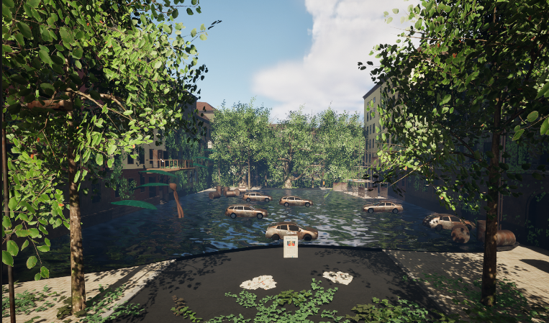
Visual Element
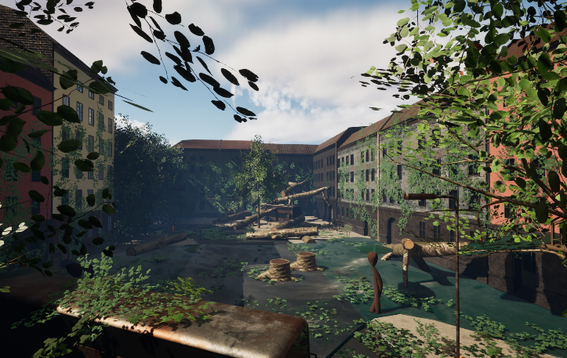

Synopsis
Verdyn is a couch co-op 3D split-screen platformer set in an overgrown, Berlin-inspired city where nature has reclaimed its space. Designed for players of all ages, the game features a robot and a sentient plant as the main characters, each with unique abilities like manipulating technology or growing platforms. Together, they must solve puzzles and overcome obstacles, with teamwork and cooperation at the core of the experience. The game offers so far one level with parkour-style movement, and a semi-realistic art style. With intuitive controls for both controllers and keyboard & mouse, Verdyn combines exciting jump-and-run mechanics with immersive sound design, delivering a fun and engaging adventure for everyone.

Goals
The player experience goals of Verdyn include delivering challenging and strategic gameplay that hinges on player cooperation. The game aims to provide exciting and satisfying jump-and-run mechanics, complemented by strong audiovisual appeal, ensuring a fun and engaging experience for all ages.

Game World & Game dynamics
Set in an overgrown, abandoned city inspired by Berlin, this 3D platformer has players controlling a robot left behind by humans and a curious plant that follows it on its journey. The robot’s mission is to reach the iconic Fernsehturm and release a signal that will destroy all plant life. As players work together to solve puzzles and overcome obstacles, they uncover the story of the city’s abandonment through collectible notes scattered throughout the levels. The game emphasizes teamwork and strategic gameplay, requiring players to combine their abilities to navigate challenges in a visually immersive world. With its strong audiovisual appeal, exciting jump-and-run mechanics, and intuitive controls, the experience is designed to be fun and engaging for players of all ages, making the journey both immersive and rewarding.

Characters
We have a robot and a plant as the playable characters. Both characters are the same size, can push, ‘walk’, run & jump, but they also have different abilities, like interacting with technology as a robot and interacting with nature and growing platforms as a plant.
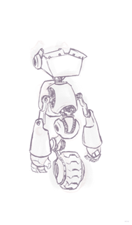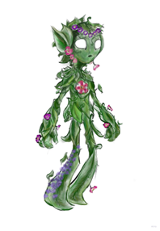

Mechanics
- balancing platforms
- Moving Platforms
- Trampoline
- Vanishing Platforms
- Pushing Players
- Buttons
- Switches
- Controllable Platforms
- Wall Jumps

Sound
Sound in this game is used as a response to the players actions but also with surface sounds and ambient sounds to create an immersive feeling.

Technology
Game Engine: Unreal Engine 5 Version 5.4
Version Control: Perforce
3D Assets: Blender
2D Assets (UI): Adobe Photoshop/Illustrator

